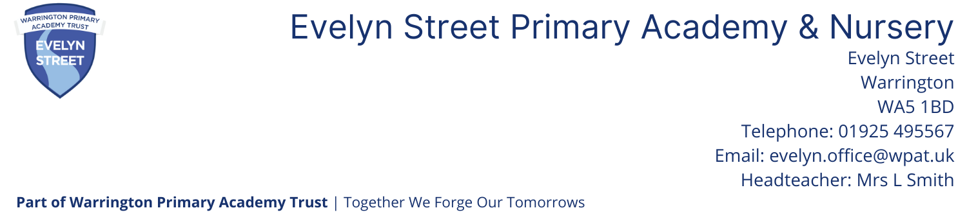

Full Time Higher Level Teaching Assistant
Commencing September 2024
Grade 6 Point 15 £27803 FTE (pro rata accordingly) pending pay award
Fixed Term for 1 year/Term Time plus 1 week (Possible extension depending on funding)

Warrington Primary Academy Trust and The Governing Body of Evelyn Street Primary School would like to appoint a motivated, inspiring and dedicated HLTA to join an excellent team of staff committed to delivering the highest standards of education.

Applicants will need to:

- have the skills to support and challenge children of all abilities and needs to ensure they make good progress by engaging and supporting children in their learning through a variety of strategies, adjusting activities for the pupil they are working with to support learning styles and individual needs
- have high expectations of what children can achieve and share our ambition in ensuring the very best for our pupils and their families
- have a good knowledge of the National and EYFS Curriculum, group interventions and assessment in primary education
- have an understanding of confidentiality and safeguarding
- have experience in class supervision, PPA cover and CPD/absence cover with the confidence and ability to teach whole classes across the primary phase and plan lessons accordingly
- have excellent interpersonal skills to work with children and parents
- be positive, proactive and have the ability to be reflective and strive for self-improvement
- be highly motivated and able to plan and work independently and under their own initiative
- be a team player who can work with their partner HLTA and other staff, developing positive relationships with colleagues
- have the HLTA qualification or equivalent
- has a positive approach to managing children’s behaviour
- Engage in all aspects of school life

We can offer the successful candidate:
- An Outstanding School (Ofsted 2011)
- A welcoming, caring and fully inclusive ethos
- Pupils with exemplary conduct, outstanding behaviour and positive attitudes to learning
- Outstanding role models for teaching
- An exciting and effective Creative Curriculum
- Supportive staff, parents and governors
- Excellent professional development opportunities

Prospective candidates are welcome to visit the school by appointment. All candidates are required to read our Safeguarding and Child Protection policy which is available to download on our website www.evelynstreetschool.co.uk

Our school is committed to safeguarding and promoting the welfare of children. The successful candidates will be required to apply for enhanced disclosure from the Disclosures & Barring Service. Further details can be found on homeoffice.gov.uk/agencies-public-bodies/dbs/

The application form and further details are available to download from our website:

www.evelynstreetschool.co.uk

All applications should be marked for the attention of the Head teacher Mrs Smith

School Visits: Please contact the school office
Closing date: 12 noon Friday 5th July 2024
Shortlisting: Friday 5th July 2024
Interviews: Week commencing 8th July 2024

